Y100- (5G)-10.1 inch multifunctional rugged tablet android

Y100-5G is a multifunctional rugged tablet developed independently by LQVIS. 10.1-inch high-definition large screen, equipped with high-performance processor; 5G communication 8-core 2.7GHz, WIFI, GPS, BT. Android 13 operating system, standard memory: 4GB+64GB; Optional: 6G+128G, 8G+128G, 8G+256G. Built in 10000mAh high-capacity battery with IP67 protection level. Supporting optional options: barcode, QR code scanning, NFC， Ultra high frequency RFID module, fingerprint module, RTK high-precision positioning module, night vision camera, thermal imager, UWB ranging positioning module and other modules. Strong industry adaptability, widely used in livestock breeding management, bank material management, military equipment material management, clothing inventory, warehouse management, smart factories, medical, municipal and other application fields. Help users quickly achieve information management and improve enterprise operational efficiency.
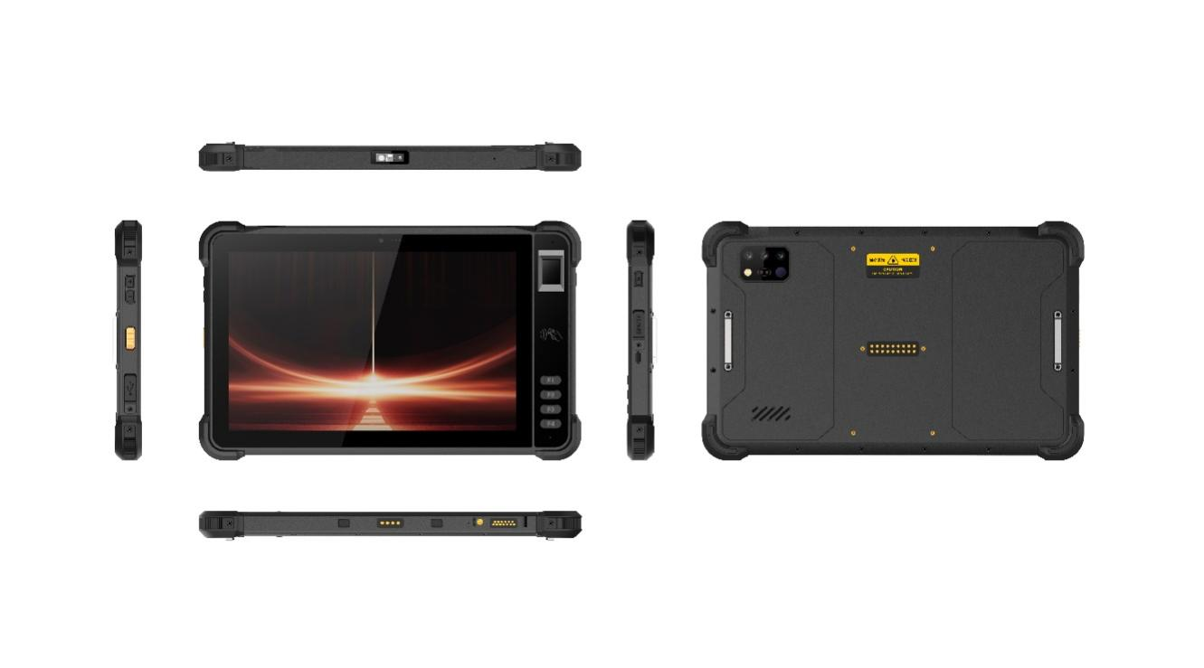

Basic Information
processor | UNISOC 7885（ 1*A76@2.7GHz+3*A76@2.3GHz+4*A55@2.1GHz）
operating system | Android 13
Memory (RAM+ROM) | 4GB +64GB ； Optional: 6G+128G; 8G+128G； 8G+256G
Expand memory | Micro SD card, supports up to 512GB
display | 10.1 inches, resolution: 800 * 1280 550 nits.  Optional: 10.1-inch/1920 * 1200/IPS 600nits/Supports glove mode/wet hand mode
Touch Screen | Capacitive screen: supports multi touch and glove touch
Rear camera | Rear 1600W pixels support autofocus and flash
Front Camera | Front 500W pixel (optional)
audio | Main MIC * 1, noise reduction and echo cancellation * 1
audio | Speaker (4W) * 1
prompt | 2 RGB lights
prompt | Vibrating motors
keystroke | Left: Volume +-, Scan key  Right side: Power on button  Front: 4 custom function keys
External interfaces | Left: TYPC-A  Right side: SIM card holder+TF card holder, TYPC-C
Booths | Nano SIM card * 2&Nano SIM card x 1+T_FLASH * 1
sensor | Light proximity sensor, gravity sensor  optional :Compass, air pressure sensor
battery | 10000 mAh polymer lithium battery,  Standby time> 350 hours  Working time> 12 hours (depending on the usage environment)  The charging time is 3-4 hours, using the standard power adapter and data cable  10000 mAh + larger battery (customized).
Charging method | Type-C 30W PD fast charging
Communication Transmission
WLAN function | 2.4/5G, 802.11a/b/g/n/ac
Bluetooth | BT5.0
GNSS | GPS/GLONASS/Galileo/Beidou, L1
Wireless WAN (Network Frequency) | 5G NR: n1/n3/n5/n8/n28/n41/n78/n79  LTE-FDD: B1/B3/B5/B8  LTE-TDD: B34/B38/B39/B40/B41  WCDMA: B1/B5/B8  GSM: B3/B8
Optional functions
Front Camera | Front 500W pixel (optional)
High definition and bright screen | 1920 * 1200/IPS 600nits/NTSC 72%/contrast ratio 1200:1/7H cover/10 point touch/industrial grade touch IC/support glove mode glove thickness ≥ 3mm/support wet hand mode
sensor | Compass, air pressure sensor
NFC（optional） | Operating frequency: 13.56MHz  Support agreement:：ISO14443A/B, ISO15693, NFC-IP1, NFC-IP2  Tag standard: M1 card(S50, S70), CPU card, NFC tag, etc  Reading and writing distance: 1-3cm
Barcode Scanning（optional）
Scan engine | E60\CM60\N1
1D Symbologies | UPC/EAN, Code128, Code39, Code93, Code11, Interleaved 2 of 5, Discrete 2 of 5, Chinese 2 of 5, Codabar, MSI, RSS, etc.
2D Symbologies | PDF417, MicroPDF417, Composite, RSS, TLC-39, Datamatrix, QR code, Micro QR code, Aztec, MaxiCode; Postal Codes: US PostNet, US Planet, UK Postal, Australian Postal, Japan Postal, Dutch, Postal (KIX), etc.
UHF RFID（optional）
Engine | module based on lmpinjE710
Operating frequency | North America: 902-928MHz FCC (NA, SA)  Europe: 865-868MHz (ETSI)  China: 920-925MHz (CMIIT)  Full frequency range: 860-960MHz (OPEN )
Protocol | EPC global UHF Class 1 Gen 2 (ISO 18000-6C)
Antenna | Circular polarization, 4dBi
Power | 1W(30dBm, +5dBm to +30dBm adjustable)  2W Optional ( 33dBm, for Latin America, etc.)
Max Read Range | Up to 15 m (open outdoors, lmpinj MR6 tag)
Fastest Read Rate | 150+tags/sec
Engine（optional） | module based on lmpinj E510
Engine（optional） | module based on lmpinj indy R2000
fingerprint（optional ） | One touch can obtain a complete fingerprint image,with effective pixels of 256 *360 and a resolution of 508DPlquickly and accurately identifyingfingerprint information
Environmental parameters
Operating temperature | -20℃~55℃  *For safety reasons, do not charge in a low temperature environment
Storage temperature | -40°C~70°C (without battery)
humidity | 0~95% (no condensation)
Drop Specs | The 1.2-meter concrete floor fell many times
Ingress protection | IP67
Electrostatic discharge | ±15KV (air discharge), ±8KV (contact discharge)
Development support
Development language | Java
Develop APIs | Android standard interface
Structural parameters
Dimensions (mm). | 290.6*182.5*18.5mm
Weight as standard | 980g
Equipment accessories
Standard accessories | Adapters, data cables, protective films

Provide ODM and OEM customized services
• We work closely with our partners and can provide various one-stop customized solutions.
• Appearance customization: supports customization of product nameplates, product packaging, and promotional materials.
• Hardware customization: Supports customization of functional modules and optional hardware functions.
• Software customization: supports customization of boot interface, boot program, kernel clipping, and API interface.
• Technical support: Provide SDK development kits and application software development technical services.

